Issued: September 22, 2011
Due Date: Class review at end of session
Conduct: Teams of 2
Requirements: (1) Laptop computers with Internet access and a web browser
(2) A basic spreadsheet program or simple text editor

BACKGROUND
This Case Study applies the concepts learned in sections 1.1 – 1.4 and 2.1 to a certification situation. This case study will aid you in finding the requirements using a real-life scenario, and you will use your results for Projects 1 and 2.
SCENARIO
Your first customer has given up on certifying his LOST system (Case 1), and has decided to build something simpler: a fuel-flow convertor that inputs analog DC Voltage from the aircraft’s fuel-flow transducer, and outputs digital fuel flow data in the ARINC 429 format (Figure 1). Anticipating the need for certification, your customer has prepared a specification sheet for the device (Figure 2). He also confidently states that this device is for a Part 23 (CAR 523) light aircraft operated under FAR Part 91 (CAR 604). He believes there is a TSO for Fuel-flow measuring systems, and perhaps some regulations and standards, and he would like your help to make findings of compliance against the applicable airworthiness standards.
TASKS
Using the document references that were distributed following Assignment 1, do the following:
- Research the CARs/FARs applicable to the Fuel-Flow Transducer
- Is there a TSO that applies in this case?
- Does the TSO state any performance requirements?
- Are there any Guidance Materials or Industry Documents that might apply to this certification?

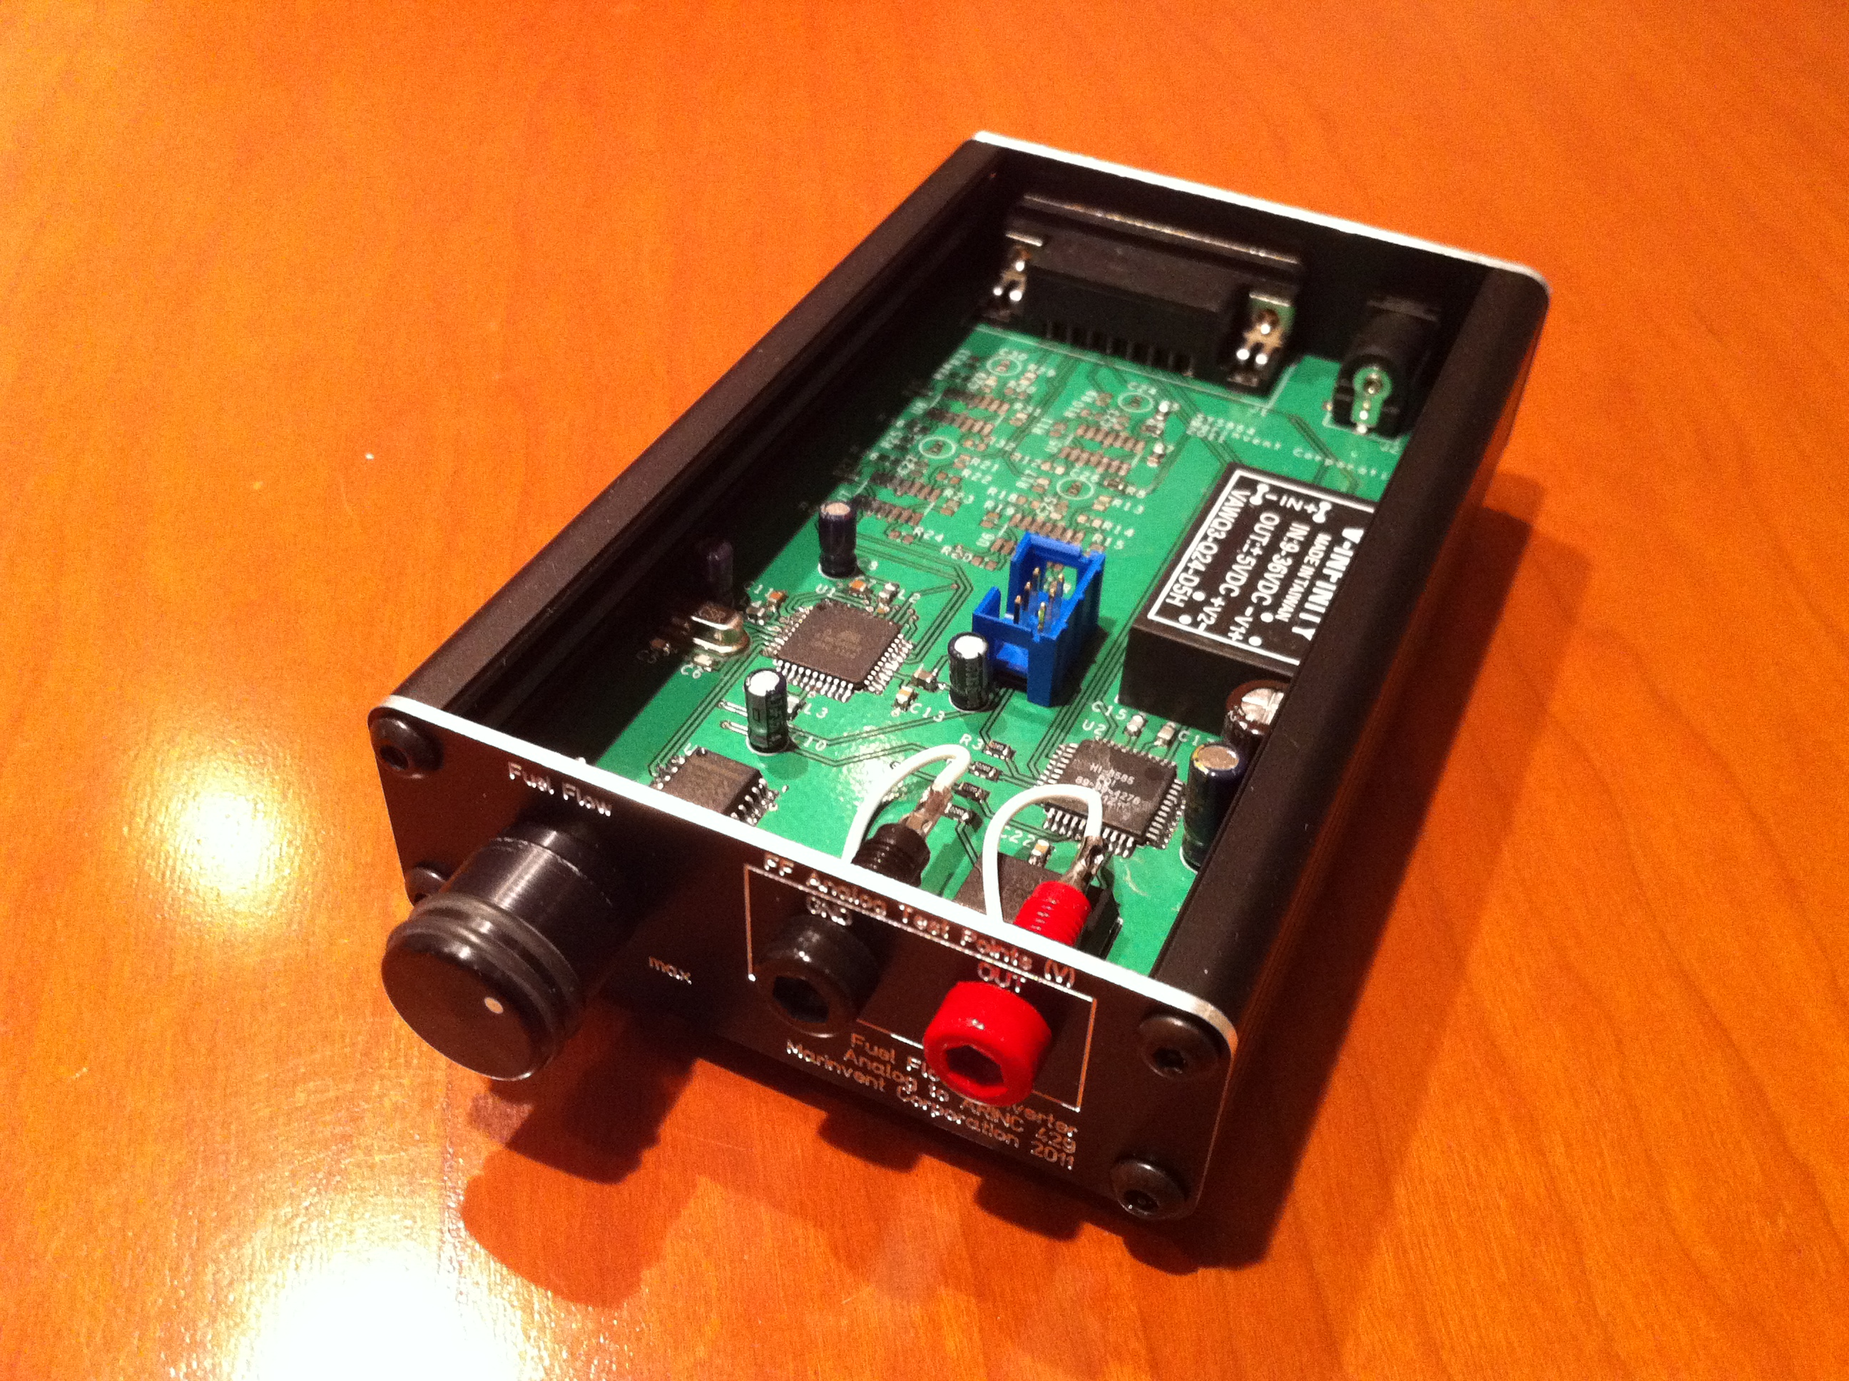
Figure 1 – Fuel-flow Converter

Model Number | FFCAD429-01
Input | 1 to 5 Volts  - 1V = 0 lbs per hour +- 2%  - 5V = 800 lbs per hour +- 2%
Output Channel Speed | Tx A429 High Speed
Enclosure | Aluminum
Dimensions | 145mm x 78 mm x 35mm
Weight | 0.52 Lbs  0.24 Kg
Environmental | Standard Operating Temperature: 0°C to 70°C  Relative Humidity for operation: 0 to 95% (non-condensing)
Power Requirement | 9 to 36 VDC
Power Consumption | 35mA @ 12VDC
Electrical | Standard ARINC-429 Voltage Level:  Transmit: ±10V & 0V
Certification | None  *** Not for flight ***
Additional Feature | Output FF Analog Test points
Connectors | J1: DB15 data output  DC IN: Power input  Test points: voltage output
Figure 2 - Fuel-flow Converter Specifications

ARINC 429 encoding

Label | Parameter Name | Units | Range (Scale) | Sig  Bits | Res | Min Transmit  Interval | Max Transmit  Interval
213 | Fuel Used | Lbs. | 262144 | 18 | 1 | 75ms | 125ms
244 | Fuel Flow Rate | PPH | 32768 | 16 | 0.5 | 75ms | 125ms

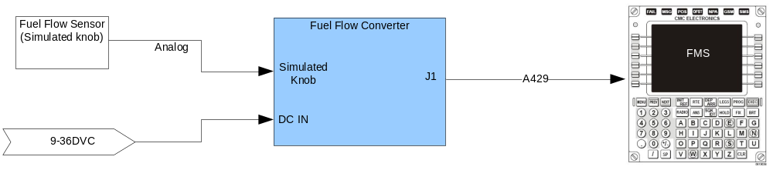

– End of Assignment –

